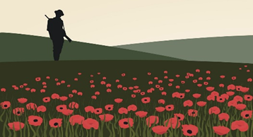 |  |   Year 5 Summer 2  Topic Overview – Sandbags and Sirens  This term, the children will be stepping back in time to explore life during the First World War in our topic, ‘Sandbags and Sirens’. They will explore what it was like for families living through wartime, from soldiers on the front line to children at home. Through stories, history and discussion, we will explore bravery, teamwork and the challenges people faced, and consider how it has shaped the world we live in today.
 |  | Super Start: On Tuesday Children will explore the British Empire and learn about the events that led to World War I, including the assassination of Franz Ferdinand. They will also create poppies and reflect on why it is important to remember. Children will spend time in our Forest School, exploring how people used the land to survive during wartime when food was limited due to rationing. |  |  |  |  |  | Educational Visit  This term we will be visiting the Imperial War Museum on Tuesday 30th June.
Our Learning Overview
PE: The children will have PE on Tuesdays.  Giraffes will be swimming this term.  Lions and Zebras will be doing Athletics. |  |  |  |  |  |  |  |  |  | Key Texts  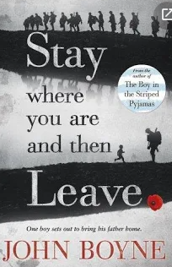  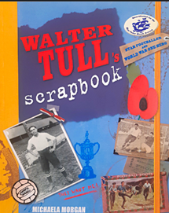
 |  |  |  |  | English |  | In English, we will be reading the book “Stay where you are and then leave”. The story follows Alfie and his father who fights in the First World War. Alfie discovers something shocking, and sets off on a journey to find his father.
 |  |  |  |  | Maths |  | This term children will be exploring position and direction, returning to consolidate their understanding and of decimals before moving on to introduce negative numbers.
 | Sandbags and Sirens |  |  |  | Science
 |  |  |  |  | History |  | In History, we will be learning all about World War I exploring who was involved, what life was like in the trenches and what no-mans land was. We will also delve into how we remember the heroes who fought for us.
 |  |  |  |  | Art |  | In Art, we will be exploring textiles. The children will design and create their own functional and practical bags for securely carrying a gas mask researching materials and practicing different stitches before making and evaluating our designs,
 |  |  |  |  | PSHE/RE |  | In RE we will be looking at the question ‘What is the best way for a Christian to show commitment to God?’
 |  |  |  |  | Music |  | In Music, the children will be having music lessons with a visiting music specialist learning a range of skills and exploring different instruments.

