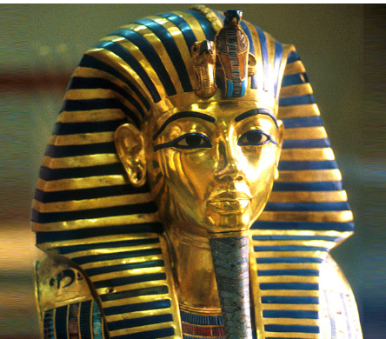 |  |   Year 4 – Summer 2.  Topic Overview – All Wrapped Up  We will be learning about the Ancient Egyptian civilization. This will include significant Pharaohs, trading and farming and social hierarchy. During the half term we will be learning about the process of mummification and how sarcophaguses were created.
 |  | Super Start: We will be looking at Egyptian paintings and hieroglyphics. We will also be using a 360 of Egypt to learn about the geography of Egypt.  Marvelous Middle – making Egyptian jewellery and trading with other classes.  Fab Finish – producing a gallery of famous Egyptian Queens. |  |  |  |  |  |  |  | Educational Visit  Workshop
Our Learning Overview
Key Texts
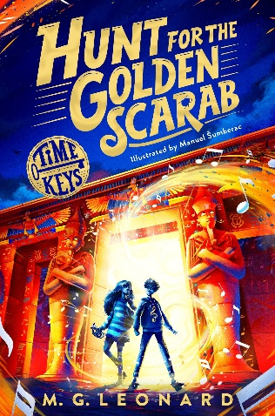
PE is on a Monday afternoon.
 |  |  |  |  | English |  | In English, we will be learning how to write a newspaper report based on the discovery of Tutankhamun. We will also write a journey tale based on a scarab beetle.
 |  |  |  |  | Math’s |  | In Math’s we will be starting the term of by looking at ‘Time’ which is such an important skill. We will then move onto Shape where we will look at a variety of different shapes, their properties and features.
 | All Wrapped Up. |  |  |  | Science |  | In Science we will be
 |  |  |  |  | History |  | In history, we will be learning about the Ancient Egyptian civilization this will include trading and farming, social hierarchy and significant Pharaohs We will be exploring the process of mummification and locating Egyptian landmarks.
 |  |  |  |  | Art |  | In Art, we will be learning about hieroglyphics – how these were produced. We will reproduce our own hieroglyphics and adding these to cartouches made from clay.
 |  |  |  |  | PSHE/RE |  | In PSHE our unit is ‘Changing Me’ we will be looking at personal characteristics and features and identifying what makes us unique. We will be looking at male and female bodies and how they change.
 |  |  |  |  | Music |  | In Music we will be consolidating our knowledge and focusing on revisiting songs and musical activities, a context for the History of Music and the beginnings of the Language of Music.

