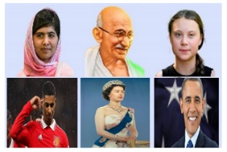 |  |   Year 1 Summer 2  Topic Overview – Stars in your eyes!  This term, the children will be exploring equality, charity and the monarchs.
 |  | Super Start:  Children to dress up as someone who has contributed to society (doctor, nurse, astronaut etc). |  |  |  |  |  |  |  | Educational Visit  Danson Park
Our Learning Overview
Key Texts

Stardust by Jeanne Willis.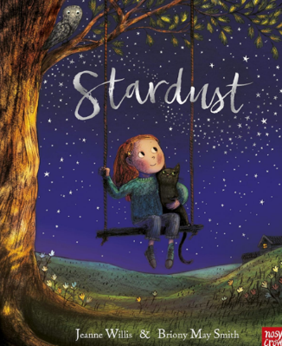
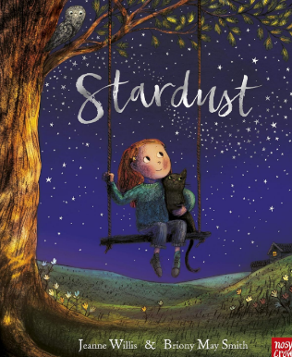
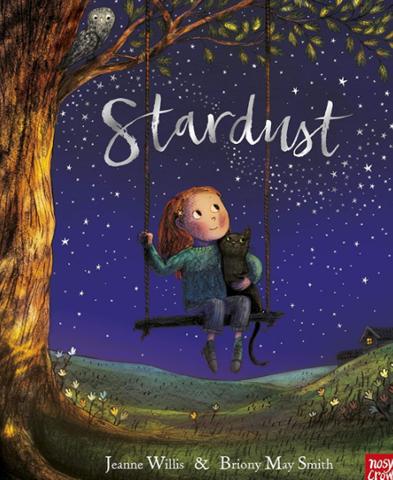
 |  |  |  |  | English |  | In English we will be looking at a range of writing styles including, recount, narrative and instructional texts. We will have a focus on nouns, adjectives and subordinating conjunctions.
 |  |  |  |  | Maths |  | In Math’s this term we will be looking at geometry, place value (within 100), Measurement (money) and time. We will also spend some time consolidating everything we have covered this year.
 | Stars in your Eyes! |  |  |  | Science |  | In science we will be looking at plants.
 |  |  |  |  | History |  | In history the children will be exploring people who have contributed to charity, people who have contributed to achieving equality. We will then be exploring two different monarchs followed by two different astronauts.
 |  |  |  |  | ART |  | In Art we will be looking at the artist Bryony May Smith and exploring how to use watercolors. We will be focusing on blending techniques as well as how to layer colors.
 |  |  |  |  | PSHE/RE |  | In PSHE this term, we will be looking at the topic ‘Changing me.’ We will be looking at how we grow and change as we get older and looking at how we are unique.  In RE, we are going to be looking at Sikhism. We will be looking at their beliefs, how they show commitment and ways they celebrate.
 |  |  |  |  | Music |  | The children will continue their weekly music sessions with Mr Krabtree.
PE - Thursday

