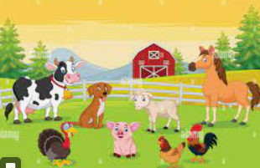 | EYFS – Nursery – Summer 2  Topic Overview – Exploring Environments  We will learn about different environments such as the jungle, polar, desert, farms, space and the seaside.
Super Start: Children may dress as their favourite animal. We will make lion faces and start to explore the jungle with our book “Rumble in the Jungle”.
Marvellous Middle: As part of exploring and taking care of nature, we will plant a seed, take care of it and watch it start to grow.
Fabulous Finish: We will celebrate our time in Ladybirds with a week of fabulous fun, including making our very own Ladybird to take home.
Our Learning Overview
Key Texts
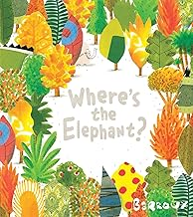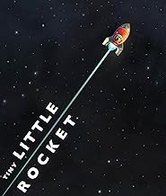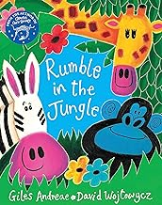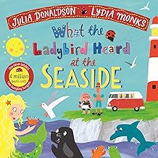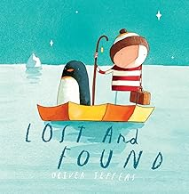

Topic vocabulary
- Forest  - Jungle  - Desert  - Ocean  - Beach  - Mountain.  - River  - Swamp  - Farm:  - Meadow:  - Arctic:  - Rocks:  - Water |  | - Forest Animals  - Ocean Animals:  - Desert Animals:  - Jungle Animals:  - Farm Animals:  - Arctic Animals:  - Swamp Animals:  - Mountain Animals:  - Trees:  - Flowers:  - Grass:  - Bushes:  - Mud: |  | - Snow:  - Sand  - Live  - Grow:  - Swim:  - Fly:  - Climb  - Hide Sleep  - Hunt  - Build  - Nests:  - Caves: |  | - Shelters:  - Coral:  - Cactus  - Pond:  - Hot:  - Cold:  - Wet:  - Dry:  - Sunny  - Muddy  - Bright  - Burrows: |  | - Rain  - Snow.  - Wind  - Fog  - Storm:  - Sunshine  - Protect:  - Recycle.  - Save:  - Preserve:  - Shady:  - Environment
Rumble in the Jungle | Where’s the Elephant? |  | What the Ladybird heard at the Seaside |  | Lost and Found |  | Tiny Little Rocket |  | On the Farm – Non fiction
- Jungle  - Animal  - Lion  - Tiger  - Elephant  - Monkey  - Snake  - Giraffe  - Rhino  - Zebra  - Cheetah  - Hippopotamus  - Roar  - Swing  - Claws  - Tropical. | - Elephant  - Hide  - Animal  - Zoo  - Find  - Search  - Under  - Behind  - Spot  - Peek  - Deforestation  - Habitat |  | - Ladybird  - Seaside  - Beach  - Sand  - Shell  - Wave  - Ocean  - Crab  - Seagull  - Fish  - Bucket  - Spade  - Castle  - Swim  - Lighthouse  - Boat |  | - Lost  - Found  - Penguin  - Boy  - Friend  - Journey  - Help  - Ocean  - Home  - Lost and Found  - Clouds  - Sky  - Sad  - Happy  - Homeward  - Return |  | - Rocket  - Blast off  - Space  - Moon  - Stars  - Planet  - Astronaut  - Journey  - Zoom  - Universe  - Sky  - Launch  - Orbit  - Milky Way  - Adventure |  | - Farm  - Barn  - Horse  - Farmer  - Tractor  - Field  - Hay  - Egg  - Wool  - Fence  - Silo  - Harvest

