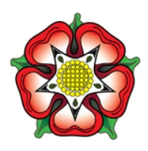 |  | Year 5 Summer 1  Topic Overview – You Wouldn’t Want to be Married to Henry VIII!  The children will be learning about Henry VIII and Tudor times. They will read many texts, both fiction and non-fiction relating to Henry VIII as well as other people’s stories in that time. Children will also dare to ask the question as to whether King Henry VIII was a good monarch or simply a tyrant!
Super Start: We will be immersing the children into Tudor life through learning about the Tudor period and creating artwork.
Fabulous Finish : Children will showcase their publish artwork and writing to their parents and carers.
Our Learning Overview
Key Texts

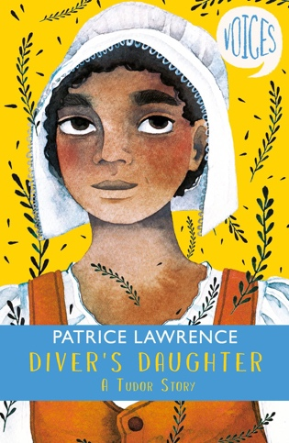
 |  |  |  |  | English |  | In English, we will be exploring the features of a discussion/persuasion text, explanation text and a split-narrative to support writing outcomes.
 |  |  |  |  | Maths |  | Students will be learning about position and direction before beginning their second decimals topic.
 | You wouldn’t Want to Be Married to Henry VIII! |  |  |  | Science |  | For our Science learning, we will be investigating the properties of materials. Children will be classifying, making observations and exploring the properties of different materials.
 |  |  |  |  | History |  | In History, we will be learning about the Tudors. Children will explore the Tudor Dynasty, the wives of Henry VIII and finally debate as to whether he was a good monarch or not.
 |  |  |  |  | Art |  | In Art, we will be creating a sculpture based on the Tudor period.
 |  |  |  |  | PSHE/RE |  | Our learning in PSHE will focus on ‘Relationships’ in which we will discuss children’s unique characteristics and qualities before exploring how to stay safe whilst using the internet. In RE, we will be studying how Hindus show commitment to God.
 |  |  |  |  | Music |  | In Music, students will be continuing to learn the violin.

