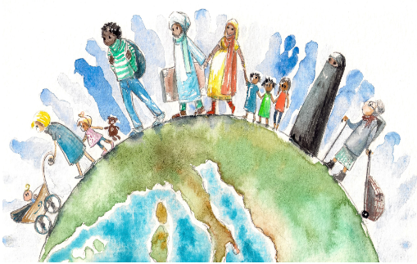 |  |  |  |  | Year 6 Summer 1  Topic Overview -  This term we will be focusing on the topic ‘You, me and all of us together’. We will start by looking at ourselves and where we fit in the world today before exploring how others live and what links us together.  SATs will be a focus for us and we will be working hard in preparation for SATs week.
Super Start: - Where in the world?
Fab Finish: - An event where we can explore other cultures and experiences.
Our Learning Overview
 |  |  |  | English |  |  | In English, we will focus on the following genres of writing: discussion, persuasion, explanation and split narrative. Our GPS lessons will focus on: modal verbs, contractions, passive verbs, colons, semicolons and descriptive devices. Some literary techniques which we will explore are: foreshadowing and creating atmosphere. We will also focus on revision in preparation for SATs assessments.
 |  |  |  | Maths |  |  | In Maths, we will continue to consolidate all of our prior learning in preparation for SATS. Our focus will be on multiplying and dividing larger numbers and fractions. Along with shape, position and direction.
 | You, me and all of us together |  |  | Science |  |  | In Science, we learn about evolution. They will explore how animals and plants develop characteristics that help them survive in their environments, and how these traits can be passed on to future generations.
 | You, me and all of us together |  |  | Geography |  |  | In Geography we will focus on who we are? Where we come from? And how we are all linked together. Our topic, ‘You, me and all of us together’ will build on our knowledge of places around the world along with our diverse population and global issues.
 | You, me and all of us together |  |  | Art/DT |  |  | In art, we will explore mixed media art and how it can be used to communicate powerful messages. We will experiment with combining materials, layering techniques, typography and stencilling, before applying our skills to design a Windrush-inspired poster. The unit will culminate in pupils creating a final multi-layered artwork that reflects their ideas and learning.
 |  |  |  | PHSE/RE |  |  | In PSHE, we will be exploring ‘Relationship’ and how we build and maintain them. We will look at what respectful relationships are and the steps we can take to maintain them.  For RE, we will look at Islam and ask the question - Does belief in Akhirah (life after death) help Muslims lead good lives?

