 |  |   Year 1 Summer 1  Topic Overview – ‘Life on Planet Earth’  This term children will learn about our planet, Earth. They will learn to identify the name of the land and seas that make up the United Kingdom. They will learn to name the seven seas and continents that make up our planet.
 |  | Super Start: We will be creating Earth-themed artwork using mixed recyclable materials. Please send in green and blue recycled materials for this project. Thank you.
Our Learning Overview
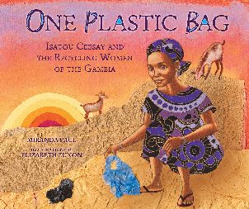
Key Texts

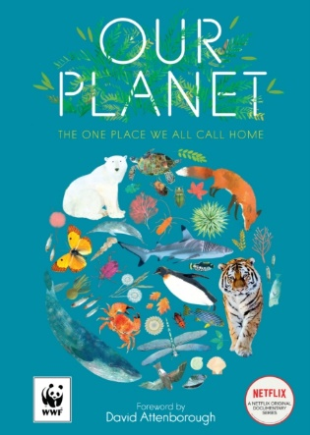

 |  |  |  |  | English |  | We will be covering key writing skills including understanding text features, composing sentences orally, and planning and writing recounts, instructions, and narratives using punctuation (capital letters, full stops, question marks, exclamation marks), plural suffixes, and conjunctions.
 |  |  |  |  | Maths |  | In Maths, we will introduce the children to multiplication and division. We will support the children to make equal groups using a range of mathematical resources.
 | Life on Planet Earth |  |  |  | Science |  | In Science, we will be learning about seasonal changes. We will be covering key science skills including observing seasonal changes and weather, identifying and grouping plants by their features and understanding how day length varies.
 |  |  |  |  | Geography |  | In Geography, our topic is ‘Life on Planet Earth’. We will be learning the names of the land and seas that make up the United Kingdom. We will identify the seven continents and the world’s oceans.
 |  |  |  |  | DT |  | This term in DT, Year 1 will explore food by learning about fruits and vegetables, safely preparing ingredients, and making a fruit smoothie. Children will design, make, and evaluate their own smoothie while developing basic cooking and practical skills.
 |  |  |  |  | PHSE/RE |  | In PSHE, we are focusing on relationships. We will identify members of our families and understand that there are different types of families. We will talk about what being a good friend means and talk about appropriate physical contact. In RE we are going to be learning about the religion of Judaism and the holiday of Shabbat.
 |  |  |  |  | Music |  | In Music, we will continue exploring rhythm, composition, tempo and exploring different instruments in our Stretto lessons.

