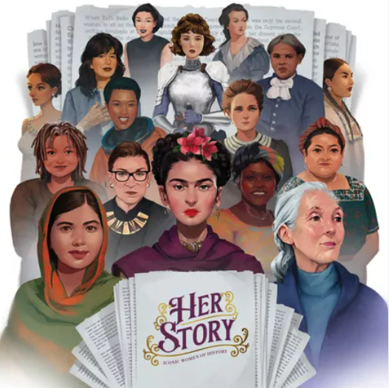 |  |   Year 2 Summer 1 - Topic Overview:  This term, children will be learning about famous women from the past and present who have made a difference in the world. We will explore inspiring people such as Mary Seacole, Rosa Parks, Wu Zetian, Frida Kahlo and Marie Curie, as well as others. We will learn about how Harriet Tubman helped to change the lives of enslaved people in North America. We will also explore the natural remedies that Mary Seacole used to care for soldiers during the Crimean War, and learn how Marie Curie, who was born in Poland, became a pioneer in science.
Super Start: For our Super Start, children will take inspiration from Frida Kahlo to create colourful self-portraits using different flowers from around the world. We will also explore and compare plants that are grown in North America with those found in the UK.
Marvellous Middle: For our Marvellous Middle, we will learn about the important lives of Harriet Tubman and Rosa Parks. Through our themes Believe and Lead and Hope and Overcome, children will explore how Harriet Tubman helped to change the lives of enslaved people in North America and learn about the impact Rosa Parks had on the American Civil Rights Movement. We will link this learning to art by creating our own paper freedom quilts.
Epic End: A workshop for parents to showcase and celebrate the children’s learning from this topic.
Educational visit: The Garden at 120
Our Learning Overview
Key Texts
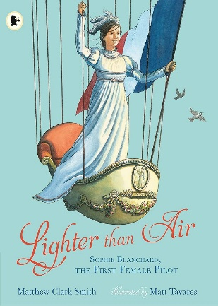

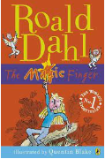
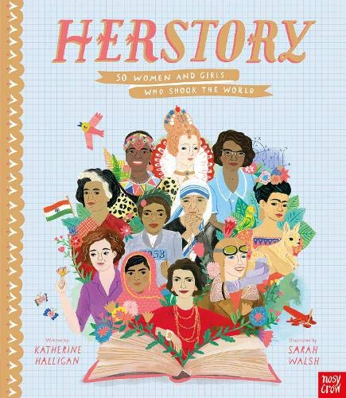
 |  |  |  |  | English |  | This term, we will be writing an adventure tale describing the adventure of Sophie Blanchard. We will also be sequencing to help write a biography or an obituary about one of the heroes studied in class.
 |  |  |  |  | Maths |  | In maths, we will be consolidating our understanding of fractions extending our knowledge to learn about unit fraction and non-unit fractions. We will also be learning about time and telling time to the next 5 minutes.
 | Herstory |  |  |  | Science |  | In science, we will be learning about plants. We will explore how seeds and bulbs grow into mature plants, and investigate what plants need to stay healthy, including water, light and the right temperature.
 |  |  |  |  | History |  | In history, we will learn about the lives of significant women who have contributed to national and international achievements and compare our lives to different periods of time, which we will allocate on a chronological timeline.
 |  |  |  |  | DT |  | In DT, children will be exploring pulleys and levers. They will experiment with different prototypes before creating their own hot air balloon.
 |  |  |  |  | PHSE/RE |  | In PSHE, we will be exploring all about our dreams and goals in school and in the wider world. In RE we will be answering the question ‘does going to a mosque give Muslims a sense of belonging?’
 |  |  |  |  | Music |  | In music, we will continue to learn the glockenspiel as well as experimenting with other instruments to learn and perform the song ‘Friendship Song’.

