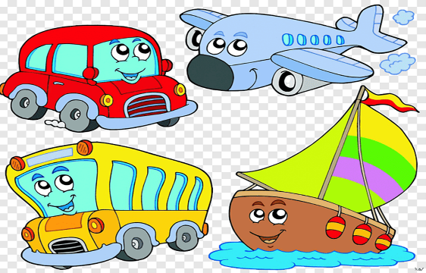 | EYFS – Nursery – Summer 1  Topic Overview – Terrific Transport  This term children will be learning about lots of different transport. They will learn all about what the transport is used for and the purpose that we need them in our world. We will look at a different book every week.
Super Start: Children to come in dressed up transport themed worker e.g. pilots, cabin crew, bus driver, cyclist, sailors, astronauts, construction workers. Back to school on 20th April 2026.
Marvellous Middle: Build a big transport town
Fab Finish: Family fun morning/afternoon
Our Learning Overview
Key Texts
The Naughty Bus by Jan Oke
Mr Grumpy’s Motor car by Jon Buringham
The Train Ride by June Crebbin
Emma Jane’s Aeroplane by Katie Howarth
Whatever Next by Jill Murphy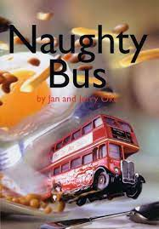

Topic vocabulary
- Car:  - Bicycle  - Train:  - Truck:  - Motorbike:.  - Boat:  - Ship:  - Airplane:  - Helicopter  - Wheels  - Engine  - Brakes  - Steering wheel  - Seatbelt | - Windshield  - Headlights  - Tail lights  - Tram  - Subway  - Taxi  - Doors.  - Horns  - Drive  - Ride  - Fly  - Pedal  - Stop Go  - Park | - Board  - Disembark  - Catch  - Drive fast/slow  - Street  - Road  - Motorway  - Track  - Bridge  - Tunnel  - Junction  - Pedestrian crossing  - Port  - Dock | - Oar  - Ferry  - Seatbelt  - Helmet  - Reflector  - Hi-vis vest  - Traffic light  - Tricycle  - Scooter  - Carousel  - Hot air balloon  - Go-kart  - Scooter:Fast  - Slow | - Speeding  - Rush  - Cruise  - Glide  - Zoom  - Take off  - Land  - Pilot  - Airline  - Airport  - Runway  - Sail  - Captain
The Naughty Bus | The Train Ride | Emma Jane’s Aeroplane | Mr Grumpy’s Motor Car | Whatever Next
- Bus  - Naughty  - Drive  - Stop  - Go  - People  - Window  - Seat  - City  - Traffic  - Mischief  - Driver  - Route  - Journey  - Friends  - Adventure | - Train  - Ride  - Track  - Station  - Whistle  - Ticket  - Passenger  - Carriage  - Chug –  - Ride  - Speed  - Outside  - View  - Stop  - Luggage  - Bumpy | - Aeroplane  - Fly  - Wings.  - Pilot  - Clouds  - Sky  - Seat  - Travel  - Take off  - Landing  - Bumpy  - Engine  - Stewardess  - Runway  - Fast  - Explore  . | - Car  - Motor  - Drive  - Road  - Stop  - Engine –  - Animal  - Journey  - Bumpy  - Fun  - Muddy  - Friendly  - Turn  - Crash  - Help  - Adventure | - Rocket  - Moon  - Space  - Bear  - Adventure  - Stars  - Night  - Up  - Down  - Space suit  - Lift off  - Home  - Cosmonaut  - Imagination.  - Play  - Friends

