 |  |   Year 3 Summer 1  Topic Overview – Who Stole the Ice?  This term, we will be setting sail into the past and embarking on a journey through history, exploring the tragic tale of the Titanic.
Super Start: Creating time lines and maps of the Titanic’s journey.
Epic End: Learning Showcase
Our Learning Overview
Key Texts

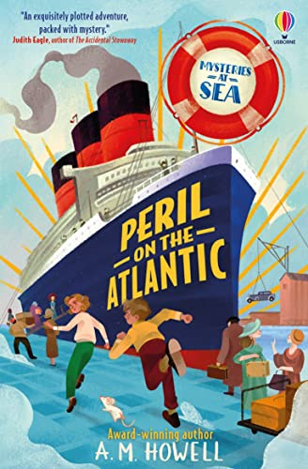
 |  |  |  |  | English |  | In English the children will be reading Peril on the Atlantic by A.M. Howell. The children will be using their understanding to write an adventure story based on a ship. Furthermore, the children will write a diary entry for a day on board the Titanic.
 |  |  |  |  | Maths |  | In Maths we will be building upon our understanding of ordering fractions, comparing fractions as well as, adding and subtracting fractions. Furthermore, we will move on to look at mass and capacity. We will be able to use our knowledge of measuring to help develop our understanding.
 | Who Stole the Ice? |  |  |  | Science |  | In Science, the children will be learning about Plants. The children will learn about the importance of plants and the structure of plants. The children will have an opportunity to plant seeds and watch how the plants grow and develop.
 |  |  |  |  | History & Geography |  | In History, we will learn about the Titanic and its journey. The children will build on their knowledge of important events and use maps, atlases and globes to locate countries in Europe, North America and the Polar regions. They will also describe some of the key features of these places.
 |  |  |  |  | Art |  | In Art, we will be exploring the work of land artists Andy Goldsworthy and Richard Shilling, looking at how natural materials can be used creatively. The children will experiment with clay and natural forms, designing their own clay imprints inspired by nature.
 |  |  |  |  | PSHE/RE |  | In PSHE, the children will be looking at relationships that they have with people around them, including their family relationships and friendships.  In RE, they will be learning about Sikhism. They will be looking at whether Sikh’s beliefs help them to place importance on sharing and lead a better life.
 |  |  |  |  | Music |  | In Music, we will be continuing our lessons through listening, singing, and performing, while also developing our understanding of rhythm and exploring how to play simple melodies on the glockenspiel.

