
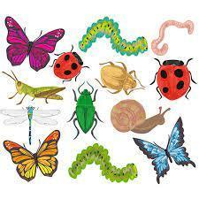 |   Reception Summer 1  Topic Overview – Marvellous Minibeasts  This term in Reception, we will continue to learn through carefully chosen key texts. We will learn through the stories, and continue to follow White Rose Maths. We will continue to follow Little Wandle and practise our writing daily.
Super Start: We will undertake many fun activities to launch our topic such as making edible minibeasts and going on bug hunts.
Epic End Parents and carers are invited in for another Family Fun Morning session – date will be posted on Dojo.
Please ensure that your child has their reading folder with their book inside every day and you are recording daily reading in their contact book. Thank you for your support with this.
Hall Place Trip - Thursday 14th May 2026
Our Learning Overview
Marvellous Minibeasts  Communication and Language  To listen to a range of stories and discuss story settings, events and characters. To learn and use minibeast related vocabulary e.g, the names of a variety of insects.  Personal, Social and Emotional  To be able to express my own feelings and be able to consider the feelngs of others. To be able to show resilence and perseverance in the face of challenge. To continue to build and develop constructive and respectful relationships. To see themselves as a valable individual.  Physical  We will develop the overall body strenght, co-ordinaton, balance and agilty needed to engage successfully . We will continue to develop our small motor skills so that the children can use a range of tools competently, safely and confdently. To develop the foundations of our handwritng style.  Literacy  We will be looking at Phase 3 sounds. To be able to read words with different sounds in by segmenting and blending. To be able to read a number of tricky words on sight. To be able to re-read books to build up confidence in word reading, their fluency and their understanding and enjoyment.  Mathematics  To be able to subitse and count numbers accurately to 20. To understand the one more/one less than relationshp between consecutive numbers. Tbe able to explore 3D shapes.  Understanding the World  We will be designing and making a bug hotel and be going on a bug hunt. We will also be looking at different habitats and things that minibeasts needs to survive.  Expressive Arts and Design  We wlil create collaboratively, sharing ideas, resources and skills. To listen attentvely, move to and talk about music, expressng their feelings and responses. To develop more complex storylines in their pretend play |  | 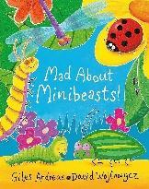  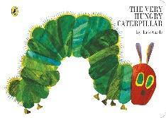  Key Texts  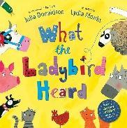  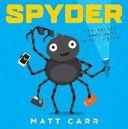  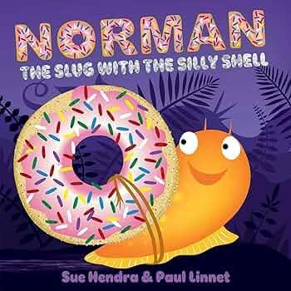  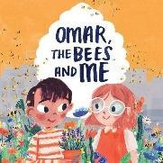

Topic Vocabulary
Insect  Spider  Ladybird (Ladybug)  Ant  Bee  Butterfly  Caterpillar  Dragonfly  Grasshopper  Moth | Beetle  Worm  Snail  Slug  Fly  Spider  Woodlice  Head  Thorax  Abdomen | Legs  Antennae  Wings  Shell  Eyes  Mouth  Spines  Antennae  Fly  Crawl | Hop  Buzz  Spin  Cocoon  Swarm  Hide  Pollen  Pollinate  Nest  Migrate | Shed  Garden  Soil  Flower  Tree  Leaf  Pond  Under a rock  Log  Grass | Catch  Watch  Explore  Slimy  Egg  Larva  Pupa  Adult  Metamorphosis  Hatch
Mad About Minibeasts | Spyder | What the Ladybird Heard | Norman the slug with a silly shell | The Very Hungry Caterpillar | Omar the Bee and Me
Minibeasts  Insect  Spider  Wings  Ant  Ladybird  Caterpillar  Butterfly  Bee  Crawl  Web  Pollen  Larva  Chrysalis  Flowers  Nest  Chomp  Explore  Hatch  Buzz | Spyder  Spider  Web  Legs  Spin  Silk  Crawl  Insect  Catch  Adventure  Scary  Small  Hide  Home  Fly  Hunt  Climb  Scurry  Frightened  Sticky | Ladybird  Farm  Animals  Heard  Whisper  Plan  Cows  Pigs  Sheep  Horses  Bags  Thief  Quiet  Secret  Steal  Clever  Escape  Chase  Hide  Farmyard | Slug  Shell  Silly  Sticky  Trail  Garden  Snail  Friend  Fit  Shell-less  Slow  Look  Try  Funny  Problem  Creative  Unique  Cover  Shape  Home | Caterpillar  Hungry  Eat  Leaf  Food  Day  Egg  Grow  Change  Butterfly  Colour  Small  Big  Stomach  Week  Fruit  Full  Sleep  Cocoon  Wings | Bees  Hive  Honey  Flower  Pollinate  Buzz  Insects  Nectar  Wings  Garden  Plant  Pollination  Pollen  Bumblebee  Buzzing  Collect  Nature  Beekeeping  Environment  Friendship

