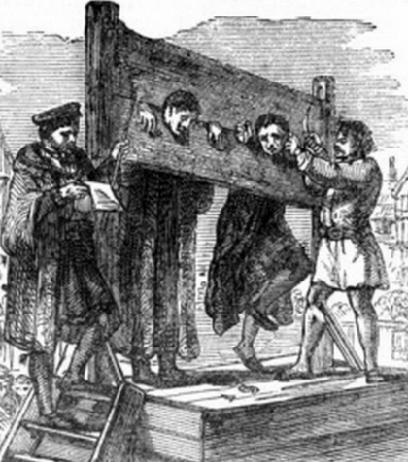 |  |   Year 6 Spring 1  Topic Overview –  During this half –term, students will be exploring aspects of life during the Second World War. In Year 6, children will be investigating the roles of significant leaders during this war and what warfare actually was like during that time. Furthermore, the students will be learning about daily life during the Second World War too.
 |  | Super Start:  Our Super Start will involve students dressing up in clothing that resembles the Second World War. Thereafter, there will be some drama reflecting life during the war.  Fab Finish:  Children in Year 6 will cook food that was eaten during the Second World War. |  |  |  |  |  |  |  | Educational visit:  WW2 workshop
Our Learning Overview
Key Texts

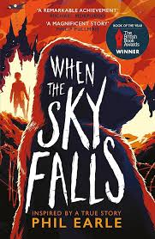

 |  |  |  |  | English |  | This term, we will be writing persuasive pieces, a narrative and explanation text around WW2. We will be ending the term by writing poetry where we will use a range of figurative language.
 |  |  |  |  | Maths |  | In Maths, we will be focusing on the four operations. This is in order to help with fluency for the arithmetic paper. Moreover, the focus will be on fractions and the four operations in relation to them.
 | Keep Calm and  Carry on |  |  |  | Science |  | In Science, we will be learning about living things and healthy lifestyles. This will involve  looking at all aspects about what contributes a healthy life style. This will include diet and  exercise.
 |  |  |  |  | History / Geography |  | The students will be using their mapping skills to locate countries which were significant during the Second World War. Then, Year 6 will have a look at how the landscape has changed during and after the Second World War too. In addition, Year 6 will explore the challenges those who lived during the Second World War had to face.
 |  |  |  |  | Art/DT |  | In Art, we will be building on our knowledge of sculpting to create clay poppies. After formed and dried, we will paint and vanish them, ready for display.
Our PE day will be on Tuesday’s. Please bring the appropriate kit. |  |  |  |  | PSHE/RE |  | In RE, the students will be analysing the concept of ‘eternity.’ They will link this concept to different religions and those who do not believe in a religion too.  In PSHE, we will learn about diversity and difference as well as how to handle discrimination and how we all can support community cohesion!
 |  |  |  |  | Music |  | We will continue working with our music teacher Ms Duggard on playing the violin, learn simple scales, like G and D major, to improve finger placement and intonation and we will also begin practicing different bowing techniques such as staccato, slurs, and dynamics.

