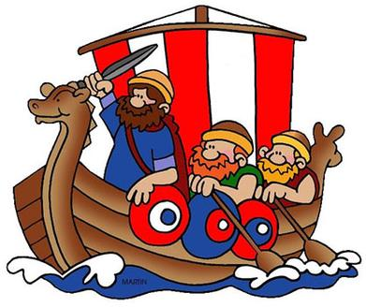 |  |   Year 4 – Spring 1  Topic Overview – Raid, Invade, Stayed  This term we will be learning about the Vikings and their civilization. This will include significant identifying significant Vikings, exploring the impact they have on Britain and how this has changed modern-day Britain. We will then use our knowledge to compare a range of historical periods.
 |  | Super Start: Children will be learning about the Roman Alphabet, learning army tactics and playing Roman games.  Marvelous Middle: Year 4 trip to Lesnes Abbey.  Fab Finish: Showcase for parents |  |  |  |  |  |  |  | Educational Visit  Lesnes Abbey
Our Learning Overview
Key Texts

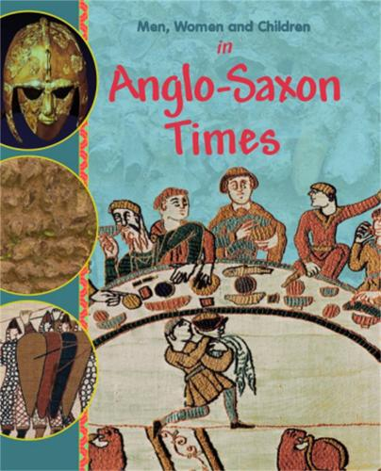
PE continues to be on Monday – remember your PE kits.
 |  |  |  |  | English |  | In English, we will be using ‘How to Train a Dragon’ as the text to support our writing. We will be writing an adventure tale, explanations texts about the ways they lived and writing our own poems.
 |  |  |  |  | Maths |  | Students will be learning about multiplication and division. We will be multiplying and dividing by 10 and 100. We will then be applying our understanding to multiply a range of 2 and 3-digit numbers.
 | Raid, Invade, Stayed |  |  |  | Science |  | As active scientists we will be looking at Electricity. We will using problem-solving and  observation skills to create circuits using switches.
 |  |  |  |  | History |  | In History we will be building upon our knowledge of Romans in Year 3 to identify how the Vikings changed Britain and comparing it to modern-day Britain. We will then be able to compare historical periods and identify significant Viking people.
 |  |  |  |  | DT |  | In textiles we will be using a range of creative approaches for our topic Raid, Invade, stayed we will create our own illuminated letter using a range of materials and range of sewing techniques.
 |  |  |  |  | PSHE/RE |  | In PSHE we will exploring what it means to be determined and aspirational through our ‘Dreams and Goals’ unit. This will involve looking sharing our dreams and things we hope to achieve in life. In RE we will be building upon our understanding of Buddism.
 |  |  |  |  | Music |  | In Music, we be learning how to play the glockenspiel to accompany songs and on its own. We will also be learning about musical rhythms and applying our understanding when playing musical instruments.

