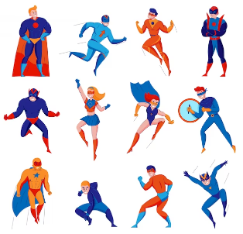 |  | 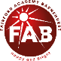  Year 3 Spring 1  Topic Overview – Do all Heroes wear capes?  This term, the children are looking at local heroes. We will be identifying where these heroes are in comparison to our school. The children will be able to identify 4 figure grid references by the end of this term and recognise how maps have changed over time.
 |  | Super Start:,The children will dress as superheroes for the day. They will be looking at local heroes and identifying where they are on a map. We will also use our map skills for some orienteering on the school site. |  |  |  |  |  |  |  | Educational Visit  Fossils and soils workshop.
Our Learning Overview
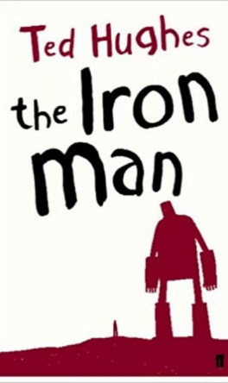
Key Texts

 |  |  |  |  | English |  | In English, the children will be reading ‘The Iron Man’, and will be using this to inform our writing. We will be writing to persuade, explain and creating some poetry. We will also be looking at the different SPaG skills to include in our writing.
 |  |  |  |  | Maths |  | As mathematicians, the children will be completing their learning on multiplication and division and then moving on to length and perimeter. Our focus will be on millimeters, centimeters and meters. By the end of the term children will be able to add and subtract different lengths and compare them.
 | Do all Heroes wear capes? |  |  |  | Science |  | As scientists, the children will be learning about animals including humans. We will be looking at healthy eating and the human body. We will be exploring the human skeleton and the different organs our skeleton protects.
 |  |  |  |  | Geography |  | In Geography this term, the children will be exploring maps. They will be looking at map symbols, using digital maps and using their map knowledge to partake in a walk around the local area. They will also be looking at how maps have changed over time due to rise in manmade structures.
 |  |  |  |  | Art |  | As artists, the children will be learning about Bruno Del Zou. They will be creating observational self-portraits, creating realistic drawings and finally a self portrait collage using drawings and photography.
 |  |  |  |  | PSHE/RE |  | In PSHE this term, we will be focusing on our dreams and goals.  In RE, we are going to be looking at Christianity. In particular, the children are going to be focusing on the Easter story.
 |  |  |  |  | Music |  | As musicians, the children will be focusing on the song No Place Like, by Kerry Andrew. The children will be applying all their musical skills to enhance their understanding.

