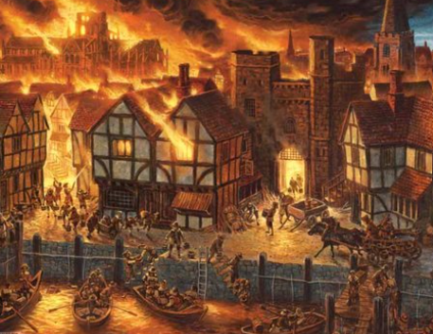 |  |  |  | Year 2, Spring 1: London’s burning  Topic Overview – This term children will looking at the events that led up to the worst fire in British history. We will be focusing on Samuel Pepys, the bakery and how people felt and reacted to the disaster.
 |  |  |  | Super Start: Children will explore the different materials used to build houses in 1066. We will discuss their appropriateness as well as being exposed to who Samuel Pepys was. Children can bring in a diary or other medium used to write to document their day just like Samuel Pepys would’ve done.  Fab Finish: Showcasing our newspaper reports. |  |  |  |  | Educational visit:  Great Fire of London workshop.
Our Learning Overview
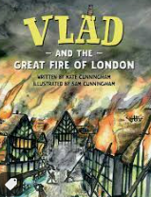
Key Texts
Vlad and the Great Fire of London.
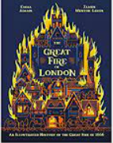
(Kate Cunningham)
The Great Fire of London
(Emma adam)
 |  |  |  |  | English |  | In English we will be children will be writing a news report about a fictional fire that has broken out in school. The children will also be writing instructions on how to put out a fire.
 |  |  |  |  | Maths |  | In Maths, we will be learning all about money. We will be looking at the value of coins and notes, as well as exploring what we could buy with a given amount of money. We will also be starting to look at multiplication and division. We will be re-focusing on the 2, 5- and 10-times tables.
 | London’s burning |  |  |  | Science |  | Children will be finding out about and describe the basic needs of animals including humans for survival. They will also describe the importance for humans of exercise, eating the right amounts of different types of food and hygiene
 | London’s burning |  |  |  | History |  | We will explore London in 1666 to understand why the wooden, crowded city was destroyed by the Great Fire. We will investigate the role of King Charles II in stopping the fire and the lasting changes to London's building rules.
 | London’s burning |  |  |  | Art/DT |  | Our key artist if Frank Bowling. We will be experimenting with different colours of paint and how we can use them to create an authentic scene, linking to our topic of the Great Fire of London.
 |  |  |  |  | PHSE/RE |  | In PSHE in Spring 1, we are looking at dreams and goals. We will focus on school dreams and goals and also those for our futures. In RE we will be focusing on Islam. We will learn about Islamic beliefs, the place of worship and the rituals they follow.
 |  |  |  |  | Music |  | Children will continue to build their understanding of song as well as having continued exposure to a variety of instruments.

