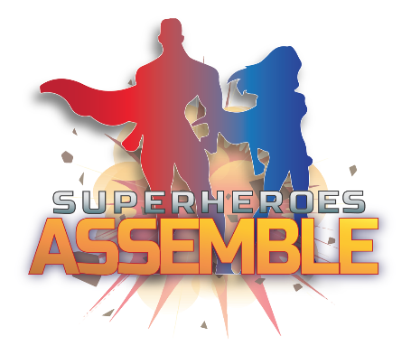 |   Reception Spring 1  Topic Overview – Superheroes Assemble  This term in Reception, we will continue to learn through carefully chosen key texts. We will learn through the stories, and continue to follow White Rose Maths. We will start to learn Phase 3 phonics and continue to practise our writing daily.
Super Start: On Tuesday 6th January, children can dress up as a superhero. We will undertake many fun activities to launch our Superhero Topic. Have a look on ClassDojo to see what your child has taken part in.
Epic End Learning Showcase Friday 13th February at 2:15pm

Dragonflies will be going to Forest school this half term on Mondays. Please ensure they have their forest school kit with them.

In January, please ensure that your child has their reading folder with their book inside every day. Please write a daily comment on your child’s reading, this is good practice to support your child with reading and writing. Thank you for your support with this.
Our Learning Overview
Key Texts
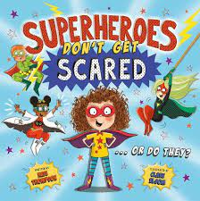
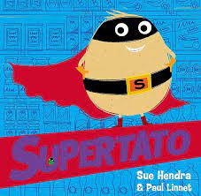
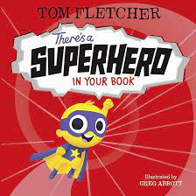
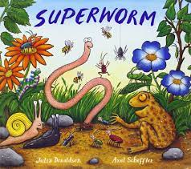

Topic Vocabulary
- Superhero:  - Hero:  - Villain  - Power  - Costume  - Cape  - Mask:  - Shield  - Team  - Secret Identity: | - Sidekick  - Lair  - Strength  - Speed  - Flight  - Invisibility  - Teleportation  - Fight  - Rescue:  - Protect | - Defend  - Help:  - Stop  - Catch:  - Attack  - Teamwork  - Plan.  - Courage. | - Good  - Evil  - Mission:  - Powerful:  - Brave:  - Heroic:  - Villainous:  - Teamwork:  - Mighty:  - Invincible | - Fearless:  - Swift:  - Loyal:  - Clever:  - Brave:  - Headquarters:  - City  - Sky:  - Lair:  - Secret Base: | - Danger Zone:  - "Up, up, and away!  - "Pow!":  - "Zap!":  - "Bam!":  - "Wham!"
Core Text Vocabulary
Supertato | Supertato | Superheroes Don’t Get Scared | There’s a Superhero in Your Book | Superworm | Supeworm
- Superhero  - Rescue  - Mission  - Trap  - Adventure | - Sidekick  - Clever  - Action  - Villain  - Superpowers  - Heroes  - Defeat | - Superhero  - Brave  - Fear  - Courage  - Power  - Scared  - Challenge  - Superpower  - Protect  - Bravery  - Fearless | - Power:  - Cape  - Costume  - Sidekick:  - Mission:  - Villain  - Danger: | - Superworm  - Hero  - Friend  - Power  - Brave  - Rescue  - Teamwork  - Villain  - Help | - Strong  - Problem  - Friendship  - Bravery  - Adventure  - Heroic

