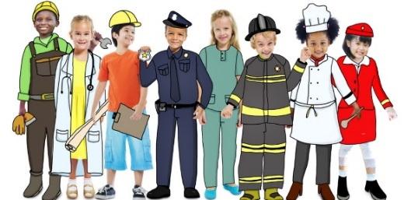 |     Nursery Spring 1  Topic Overview – Help is on the Way  This term in Nursery we will continue to learn through carefully chosen key texts. We will learn about people who help us, for example doctors, nurses, firefighters, police officers, lollipop people, teachers, adults in our family and many more!
Super Start: On Tuesday 5th January children can dress up as someone who helps us. We will explore through role play and introduce our new text ‘A Superhero Like You.’ We will immerse ourselves in activities indoors and outdoors.
Marvellous Middle- Children will get to meet some of our real-life superheroes from the emergency services.
Epic End – Learning show case 14:15 Friday 13th February 2026.
Our Learning Overview
Key Texts

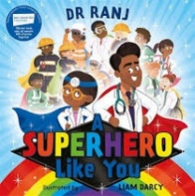
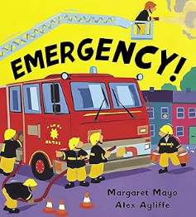


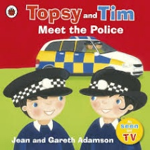

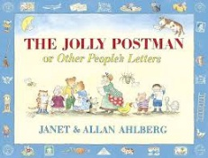
Topic Vocabulary
- Teacher:  - Teaching Assistant:  - Nursery Nurse:  - Caretaker:  - Head Teacher  - Teach:  - Cook  - Cleaner:  - Chef | - Policeman  - Policewoman  - Police station  - Prison/Jail  - Arrest  - Safety  - Care  - Help  - Emergency | - Firefighter  - Fire engine  - Fire station  - Siren  - Postman  - Postwoman  - Post office  - Delivery | - Ambulance  - Hospital  - Paramedic:  - Doctor:  - Nurse  - Surgery  - X-ray  - Medicine  - Dentist  - Teeth | - Lollipop Lady  - Listen.  - Community  - Vet  - Refuse collector  - Recycling | - Libratian  - Builder  - Mechanic  - Problem  - Service
Core Text Vocabulary
Dr Ranj a Superhero Like You | Topsy and Tim Meet the Police | Emergency | Farmer Duck | The Jolly Postman | Hospital Dog
- Superhero  - Doctor  - Kind  - Brave  - Care  - Caring  - Patient  - Friendly  - Power  - Heart  - Kindness  - Healthy  - Confidence  - Smiling  - Gentle  - Strong .  - Problem  - Solution  - Role model | - Police  - Officer  - Badge  - Car  - Lights  - Siren  - Help  - Safe  - Rule  - Crossing  - Police Station  - Question  - Uniform  - Community  - Respect  - Listen  - Talk  - Safety  - Friend | - Firefighter  - Ambulance  - Rescue  - Emergency  - Truck  - Sirens  - Rescue  - Paramedic  - Fire  - Save  - Ladder  - Save  - Danger.  - Team  - Alert  - Hurt | - Farmer  - Duck  - Farm  - Animals –  - Work  - Sleep  - Lazy  - Quack  - Barn  - Chores  - Tired  - Hard  - Funny  - Friend  - Cooperate  - Busy  - Moo  - Cluck | - Postman  - Letter  - Envelope  - Stamp  - Letterbox  - Deliver  - Post  - Address  - Happy  - Recipient  - Card  - Route  - Gift  - Town  - Village  - Bear  - Royal  - Nice  - Busy | - Dog  - Hospital  - Nurse  - Patient  - Friend  - Visit  - Comfort  - Happy  - Sad  - Tail  - Paw  - Bark  - Medicine  - Bed  - Smile  - Love  - Play  - Help  - Well

