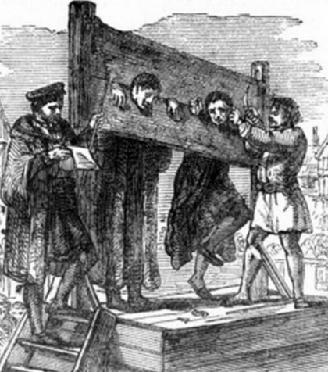 |  | Year 6 Autumn 2  Topic Overview -  This term we will be continuing out topic of ‘Crime and Punishment’. We will continue to look at crimes and punishments through the eras and how they have changed. We will use our visit to the Old Bailey to look at the why the justice system is used in everyday settings and what is in place to ensure we have a society that people are happy to be a part of.
 |  | Super Start: Children will become detectives and play a game of guess who in our ‘Who done it?’ afternoon.  Marvellous Middle: a fabulous workshop  Fab Finish: Marvelous Market Place – children will attempt to ‘sell’ their gadgets to parents. |  |  |  |  |  |  |  | Educational visit:  Workshop in school
Our Learning Overview
Key Texts

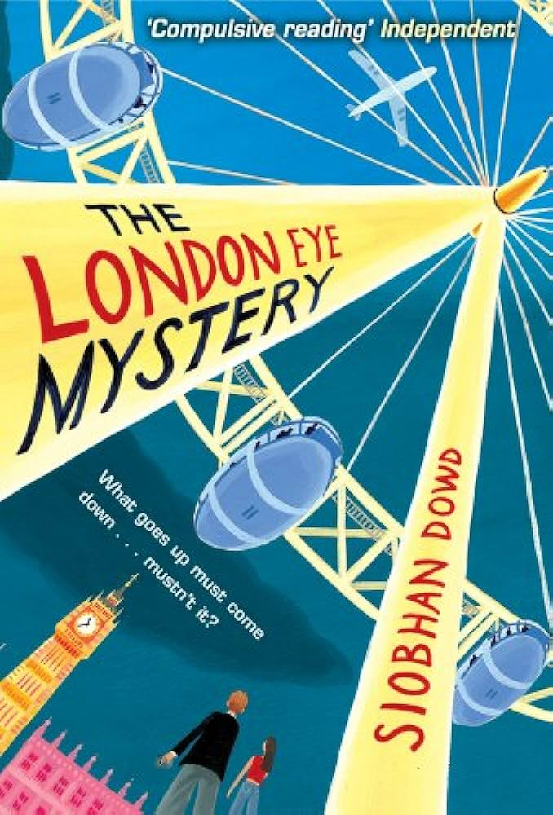

 |  |  |  |  | English |  | At the start of term we will continue by writing narratives based on the highwayman. We will then look at the book ‘The London Eye Mystery’ and write an information text and persuasive piece of writing about it.
 |  |  |  |  | Maths |  | In Maths, we will be developing our understanding of the four operations focusing on long division and order of operations. We will also be developing our fractions knowledge to solve multi-step problems and begin looking at units of measure.
 | Does the Time Fit  the Crime? |  |  |  | Science |  | In Science, we will be looking at light. By the end of this unit, we will be able to explain that we see things because of light travelling between light sources and our eyes and understand that light travels in straight lines. Our key scientist will be Thomas Edison his invention of the modern light bulb.
 |  |  |  |  | History |  | In History we will learn about crimes and there punishments. We will start by looking at Ancient Rome and then move on to the Anglo Saxon era, the Tudor era and the Victorian era. We will then look at crime and punishment during WWII, right up until today and how our laws work now.
 |  |  |  |  | Art/DT |  | In Art, we will be designing and creating our own gadget. The idea of our gadget will be linked to our English lesson and this will be the item that helps to solve the problem from our stories.
 |  |  |  |  | PHSE/RE |  | In RE, we will be exploring how Christians celebrate Christmas. We will discuss the Christmas story and the different ways in which people celebrate.  In PSHE, we will be looking at ourselves and the similarities and differences we share with our peers and the others around us.
PE - This term we will be gymnasts. We will be thinking about balancing and how we more around. |  |  |  |  | PHSE/RE
 |  |  |  |  | Music |  | In music, the children will continue to learn how to play the violin and learn to sing popular Christmas songs.

