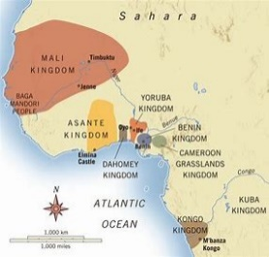 |  |   Year 5 Autumn 2  Topic Overview – The Ancient Kingdom of Benin  This term, the children will be learning about the Ancient Kingdom of Benin. They will be looking at ancient civilisations, comparing ancient and modern civilisations. The children will also look at historical sources and the significance of this society on modern-day life.
 |  | Super Start: The children will learn about the geography of the Ancient Kingdom of Benin. They will look at Benin art and attempt to make their own. The children will also learn about historical artefacts from Benin.  Fabulous Finish: Parents will be invited in to attend a culture day, bringing food to share from their culture. |  |  |  |  |  |  |  | Educational Visit  In-School Workshop
Our Learning Overview
Key Texts

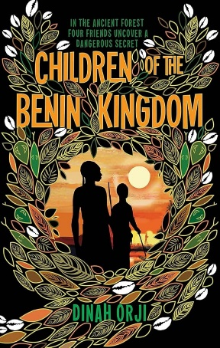
 |  |  |  |  | English |  | In English, we will be building on their use of vocabulary and varying sentence structure to write a portal story. The children will also be creating a chronological report about Benin.
 |  |  |  |  | Maths |  | Students will be focusing on their multiplication knowledge. They will then be moving on to fractions, developing an understanding of mixed number and improper fractions, as well as converting between the two.
 | The Ancient Kingdom of Benin |  |  |  | Science |  | For our Science, we will be learning about Space. The children will learn how planets orbit, looking at the contributions from key astronomers.
 |  |  |  |  | History |  | In History, we will be learning about the Ancient Kingdom of Benin. We will be looking at Benin Bronzes and seeing how Ancient Benin has impacted modern society.
 |  |  |  |  | Art |  | In DT, we will be making our own Agege bread. We will be looking at a variety of Nigerian dishes and researching about the cuisine.
PE: The children will have PE on a Tuesday. Zebras will be swimming this term. Giraffes and Lions will be doing . |  |  |  |  | PSHE/RE |  | Our learning in PSHE will focus on ‘Understanding Differences’. We will look at similarities and differences between people in our community. Our RE focus is Christianity. We will be questioning ‘Is the Christmas Story true?’
 |  |  |  |  | Music |  | In Music, students will be learning Christmas songs ready for our Christmas performance.

