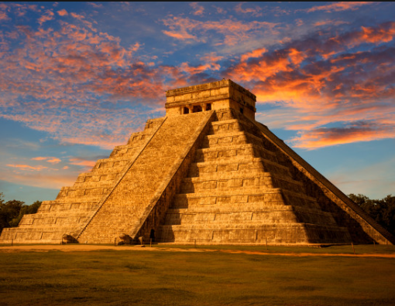 |  |  |  |   Year 4 Autumn 2  Topic Overview – Hola!  This term we will be learning all about the Ancient Mayan Civilization. We will be exploring the different periods of their civilization, alongside analysing the geographical landscape which they built upon. We will look at how they farmed and traded, alongside the social hierarchies of their states.
 |  |  |  | Super start: Monday 3rd November We will be immersed in Ancient Maya culture. We will create our own Mayan masks as well as design our own confidence building shields. Children can come dressed as Ancient Mayans.  Marvellous Middle: Mayan Chocolate Workshop  Fab Finish: Children will perform their folk tales to their parents/carers. |  |  |  | Educational Visit  Tasting and making chocolate workshop – in school
Our Learning Overview
Key Texts

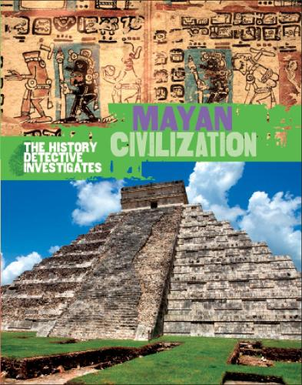

 |  |  |  |  | English |  | In English this term we will be focusing on creating their own version of the Mayan creation story. For our non-fiction, we will be writing newspaper reports about life during the Mayan civilisation as well as writing non-fiction reports.
 |  |  |  |  | Maths |  | This half term, we will be learning about area and then concentrating on multiplication and division. This will include learning multiplication and division facts and knowing the associated facts. We will be learning about commutativity and the inverse function.
 | Hola! |  |  |  | Science |  | In Science, our learning will be focussed on the topic of “Sound”. We will learn how sound travels and how the ear works, also we will investigate how sound can be insulated and if sound fades the further away the sound source is,
 | Hola! |  |  |  | History |  | In History, we will be learning about another Ancient Civilisation- the Mayans. We will build on our historical knowledge learnt earlier in the year to compare their civilization to ones previously taught. We will also focus on their inventions and discoveries which we still use today.
 | Hola! |  |  |  | Art |  | In Art, we will be exploring the work of collage artist and illustrator David Wisniewski.  We will be developing a landscape using paper collage. We will be learning different collage techniques and how to create effective foregrounds and backgrounds. Our learning will be based on the illustrations in the “Rain Player”
 |  |  |  |  | PSHE/RE |  | In PSHE our new topic is “Celebrating Difference”, We will be learning that we are all unique and therefore different but we still have qualities that make us all human.  In RE we will be looking at the question. “What is the most important part of the Nativity to Christians?”
 |  |  |  |  | Music |  | This half term, we will be learning how to play glockenspiels and to accompany ourselves while we are singing. We will learn about tune, pitch and melody.

