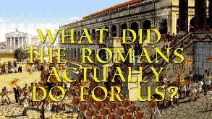 |  |   Year 3 – Autumn 2  Topic Overview – What did the Romans do for us?  The children will use their understanding to place Roman invasions accurately on a map and a timeline. The children will explore the significance of the Roman Army learn about important Roman Battles. They will also develop an understanding of what Romans did to support Britain and learn about Roman art.
 |  | Super Start: We will be immersed in Roman culture. Children can come dressed as a Roman.  Marvellous Middle: Portals to the past workshop.  Fab Finish: Parent Gallery |  |  |  |  |  |  | Educational Visit:  Portals to the past workshop in school.
Our Learning Overview
Key Texts

Escape from Pompeii

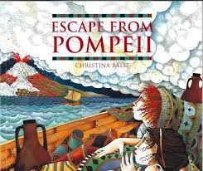
 |  |  |  |  | English |  | This term in English, the children will be looking at ‘Escape from Pompeii’. We will be writing a narrative, information text and a newspaper report. We will be working on putting our writing into paragraphs and including adverbs, conjunctions and speech.
 |  |  |  |  | Maths |  | In mathematicians, the children will be completing their learning on addition and subtraction, then starting multiplication and division. They will be looking at multiples and using times table facts to help solve number problems. They will be using their reasoning and problem-solving skills to enhance their mathematical thinking.
 | What did the Romans do for us? |  |  |  | Science |  | As scientists, the children will be learning about ‘Forces and Magnets’. We will be looking at different forces and compare how things can move. We will be observing the work of magnets and describing them. We will be working on our comparing, predicting and observing skills throughout the topic.
 |  |  |  |  | History |  | In History, the children will be looking at the Romans. They will be investigating what the Roman’s have done to help us in current life. They will be exploring Roman Britain and significant battles including Boudicca and the Battle of Watling Street.
 |  |  |  |  | ART |  | This term, the children will be creating their own Roman mosaic. They will be looking at the importance of mosaics, learning about repeating patterns and designing and making their own mosaic. These will then be showcased to parents at the end of the term.
 |  |  |  |  | PSHE/RE |  | In PSHE this term, we are going to be looking at celebrating differences between people.  In RE, we are going to be looking at Christianity. In particular, the children are going to be focusing on the Christmas Story.
 |  |  |  |  | Music |  | In Music we will be exploring different beats and rhythms. We will also start practicing Christmas songs for a performance at the end of the term.

