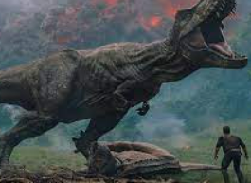 |  |   Year 2 Autumn 2  Topic Overview – Jurassic World  In this topic, children will explore the significance of Mary Anning and how her fossil hunting changed the world of paleontology. Children will explore different types of dinosaurs and use vocabulary learned to write their own narrative hunting stories.
 |  | Super Start: Children will be making significant discoveries as paleontologists: understanding how fossils are unearthed and the importance of taking care of discoveries. They’ll also perform dances, acting as different dinosaurs.  Fab Finish: Learning Showcase (dates to come) |  |  |  |  |  |  |  | Educational Visit  Natural History Museum.
Our Learning Overview
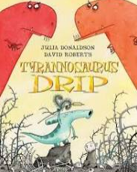
Key Texts

Tyrannosaurus drip by Julia Donaldson.

 |  |  |  |  | English |  | Children will continue to build their understanding of narrative writing: further exploring conjunctions, verbs, adjectives and commas for a list. Each week we will build sequences of writing based on the key text.
 |  |  |  |  | Maths |  | In Maths, we will be looking at addition and subtraction with 2-digit and 3-digit numbers. We will also be looking at shapes, exploring both 2D and 3D shapes and their features.
 | Jurassic World |  |  |  | Science |  | In Science this term we will be learning about living things and their habitats. Year 2 will be learning how to tell the difference between things that are living, dead and have never been alive. Our Scientist of the term will be Charles Darwin!
 |  |  |  |  | History |  | In History, we will be exploring dinosaurs as nouns, looking at timelines and understanding how long ago dinosaurs lived.
 |  |  |  |  | Art |  | This term in art we will be creating observational drawings. We will be learning a range of new techniques such as shading, sketching and the use of water colour to create lifelike images.
 |  |  |  |  | PSHE/RE |  | In PSHE this term we will be learning about “celebrating difference.” This will give us the opportunity to talk about how we are similar and different to our friends. We will also be discussing the importance of treating each other well despite our differences.
 |  |  |  |  | Music |  | In Music, we will continue to learn to find the beat in a piece of music. We will be learning about rhythm and pitch. We will be asking how music can tell stories about the past. They will be learning to perform to music in front of an audience.

