 |  |   Year 1 Autumn 2  Topic Overview – There’s No Place Like Home  The children will be exploring key human features, e.g. cities, towns and shops. They will be learning to identify the countries that make up the United Kingdom and use simple compass directions. (North, South, East and West). We will be exploring the local environment and our surroundings.
 |  | Super Start: We will be looking at different types of homes. We will design a room and use cardboard boxes and recycled materials to bring it to life! We will be going on a scavenger hunt to find key features of the United Kingdom. We will be dressing up as our dream jobs.  Fab Finish: Learning Showcase (dates to come) |  |  |  |  |  |  |  | Educational Visit  Posting letters to Santa
Our Learning Overview
Key Texts

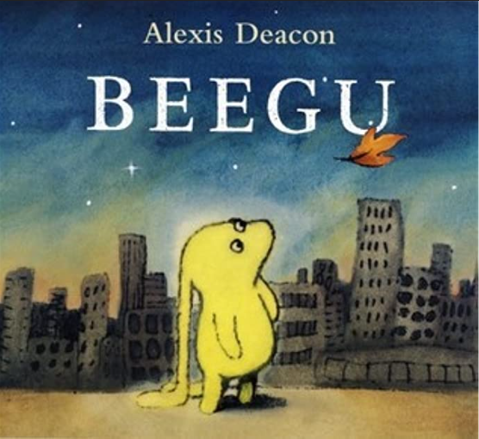
In PE we will be focusing on |  |  |  |  | English
 |  |  |  |  | Maths |  | In Maths, we be continuing to develop our knowledge of place value with numbers to 10. We will be learning to add numbers to 10 and subtract within 10. We will be learning to use the part-whole model to partition numbers. We will be learning about fact families and number bonds within 10.
 | There’s No Place Like Home |  |  |  | Science |  | For our Science learning, we will be learning about seasonal changes in Autumn and Winter. We will be observing and describing the different weather associated with the seasons and observing what happens to the plants, trees and wild life.
 |  |  |  |  | History |  | In History, we are learning about our local area. We will identify local landmarks and talk about why they are important. We will use Google Maps to navigate the local area. We will learn to name the countries in the UK and talk about different homes. We will talk about the different jobs in the community.
 |  |  |  |  | Art |  | In Art, we will be learning about printing techniques. We will explore shapes and patterns and have a go at mixing colours. We will use natural materials to make our own prints.
 |  |  |  |  | PSHE/RE |  | Our PSHE topic will be Celebrating Differences. We will look at similarities and differences between us and our friends and talk about what to do if we feel unhappy or feel like we are being bullied. We will discuss how to be a good friend and talk about what makes us special. In RE we will be learning about Christianity, focusing on the Christmas story and how it feels to receive a special gift.
 |  |  |  |  | Music |  | In Music, we will continue to learn to find the beat in a piece of music. We will be learning about rhythm and pitch. We will be asking how music can tell stories about the past. They will be learning to perform to music in front of an audience.

