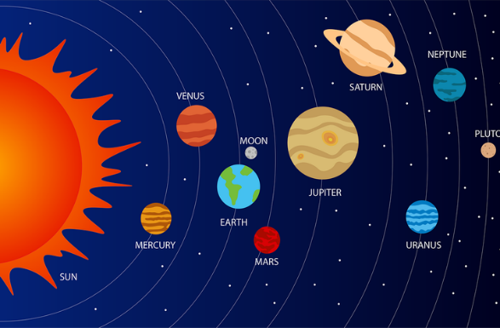 |   Reception Autumn 2  Topic Overview – Out of this World  We will be learning about space, thinking in depth about The Moon, Sun and the planets. We will be looking at traditional cultural stories about Diwali Hannukah and Christmas.
Super start - On Monday 3rd November 2024, Children can come to school dressed as a asteronaut/alien/scientist. We will undertake many fun activities to launch our topic. Keep an eye on classdojo to see what your child has taken part in.
Marvellous Middle: Children will ge the chance to experience some stories from the international space station and learn about living in space.
Epic End - Parents and carers will be invited in for a Family Fun Afternoon session – date TBC
Please ensure that your child has their reading folder with their book inside every day and you are writing in their contact book daily. Please also support your child in completing any homework given as this reinforces work in school. Thank you for your support with this.
Our Learning Overview
Key Texts

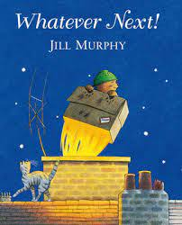
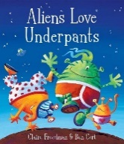
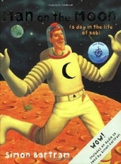
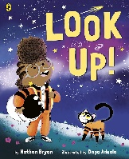
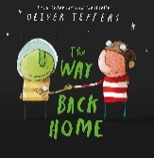

Topic Vocabulary
- Earth:  - Mars:  - Jupiter:  - Saturn:  - Venus:  - Mercury:  - Neptune:  - Uranus:  - Pluto: | - Planet  - Sun:  - Moon  - Space:  - Asteroid:  - Comet:  - Star:  - Galaxy  - Orbit:  - Satellite: | - Astronaut:  - Rocket:  - Spaceship:  - Space Station:  - Mission:  - Launch:  - Landing:  - Space Suit:  - Telescope:  - Sunshine: | - Stars:  - Crater:  - Meteor:  - Meteorite:  - Spin:  - Gravity:  - Day:  - Night: | - Seasons:  - Rocket Ship  - Space Helmet  - Solar System:  - Moon Phases:  - Earth's Atmosphere:  - Sunlight  - Explore: | - Discover:  - Observe:  - Imaginary:  - Adventure:  - Starry:  - Year:  - Month  - NASA.  - Alien:  - Astronomer:
Core Text Vocabulary
Whatever Next | Aliens Love Underpants | Look Up | Man on the Moon | The Way Back Home | Dear Santa
- Bear  - Mummy  - Baby bear  - Friends:  - Adventure:  - Fly:  - Lift-off:.  - Climb:  - Zoom:  - Blast off: | - Alien:  - Space:  - Spaceship:  - Planet  - Extra-terrestrial: | - Space:  - Astronaut  - Rocket:  - Planet  - Star:  - Moon:  - Galaxy  - Orbit:  - Telescope:  - Look up:  - Explore: | - Moon:  - Space:  - Astronaut:  - Rocket  - Spaceship  - Crater:  - Lunar:  - Gravity:  - Bob:  - Tourist:  - Alien:  - Routine:  - Solitude:  - Adventure:  - Curiosity: | - Moon:  - Space:  - Rocket  - Alien:  - Gravity.  - Stars:  - Fly:  - Crash:  - Land:.  - Travel:  - Search:  - Help: | - Santa Claus:  - Christmas  - Reindeer:  - Sleigh  - Elves:  - North Pole:  - Stocking:  - Presents  - Write  - Ask:  - Send:  - Deliver:  - Wish:  - Hope:

