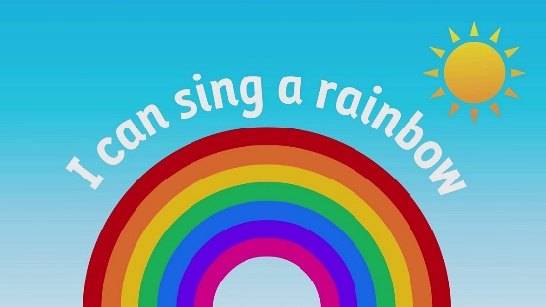 | EYFS – Nursery – Autumn 2  Topic Overview – I can sing a rainbow  This term children will be learning all the colours of the rainbow and how colours are made. They will learn all about different colours and explore what happens when different colours are mixed together. We will explore colour though activities that involve hands on exploration, creative activities and look at and taste different types of food that our the colours of the rainbow.
Super Start: Monday 3rd November children to come to nursery dressed in all the colours of the rainbow.
Marvellous Middle: Children will create their own rainbows through a range of science experiments – Keep an eye on classdojo to see what different experiments they do.
Fab Finish: Family fun morning = date TBC
Our Learning Overview
Key Texts
I can eat a rainbow By Rose Olena
The world made a Rainbow by Michelle Robinson
Rainbow Fish By Marcus Pfister
Brown Bear, Brown Bear What do you see? By Eric Carle
The Mixed up Chameleon by Eric Carle
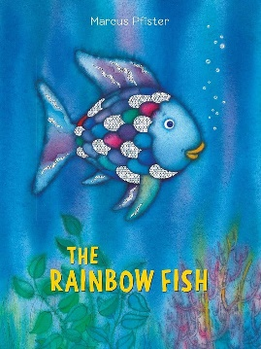

Topic Vocabulary
- Red  - Orange  - Yellow  - Green  - Blue  - Indigo  - Violet | - Rainbow  - Bright  - Colourful  - Flower  - Sun  - Look  - Colour | - Shine  - Mix  - Dance  - Paint | - Arc  - Stripe  - Circle  - Happy  - Joyful  - Excited | - Rain  - Cloud  - Sunshine  - Sky | - Storm  - Explore  - Observe  - Discover
Core Text Vocabulary
Mixed: A Story about colours | Rainbow Fish | Brown Bear, Brown Bear What do You See? | The World Made a Rainbow | I can eat a rainbow | The Mixed up Chameleon
- Mix  - Bright  - Together  - Different  - Change  - Blend | - Rainbow  - Scales  - Shiny  - Sharing  - Colourful  - Beautiful  - Generosity | - Brown  - Bear  - See  - What  - Red  - Bird  - Yellow.  - Duck  - Green  - Frog .  - Purple  - Cat  - Blue  - Horse  - Gold  - Seeing  - What do you see? | - Rainbow  - Colour  - Red  - Orange  - Yellow  - Green  - Blue  - Indigo  - Violet  - Bright  - Together  - Made  - World  - Hope  - Shine  - Happy  - Kindness  - Smile  - Create | - Rainbow  - Colour  - Red  - Orange  - Yellow .  - Green  - Blue  - Purple  - Food  - Fruit  - Vegetable  - Eat  - Healthy  - Taste  - Yummy  - Sweet  - Fresh  - Delicious  - Vibrant | - Chameleon  - Green  - Blue  - Red  - Yellow.  - Purple  - Change  - Mix  - Animal  - Tail  - Spots  - Stripes  - Shape  - Big  - Small  - Fast  - Slow  - Happy  - Sad  - Reflect

