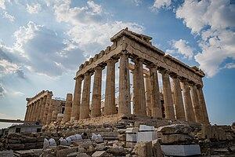 |  |   Year 5 Autumn 1  Topic Overview – Ancient Influencers  This term, the children will be learning about the Ancient Greek Civilisation. They will be looking at what the Ancient Greeks did for society, influential figures from Ancient Greece and famous battles from the time. The children will develop an understanding of a variety of Greek Myths and understand their importance.
 |  | Super Start: The children will learn all about different aspects of Greek life, from the arts, battles and the Gods and Goddesses. They will develop an understanding of where Greece is and the city-states that made up Ancient Greece.  Fabulous Finish: Children will showcase their learning from the term to parents, including their finished vases. |  |  |  |  |  |  |  | Educational Visit  The British Museum
Our Learning Overview
Key Texts
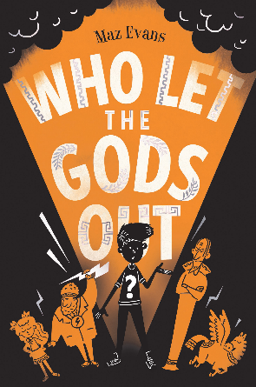

 |  |  |  |  | English |  | In English, We will be completing a range of writing including narrative, recount and persuasive text based on our reading text.
 |  |  |  |  | Maths |  | Students will be building their place value knowledge by exploring Roman numerals, ordering and comparing numbers up to 1,000,000 and the partitioning of numbers.
 | Ancient Influencers |  |  |  | Science |  | For our Science learning, we will be investigating different forces. Children will take part in a variety of practical lessons to aid their understanding.
 |  |  |  |  | History |  | In History, we will be learning about Ancient Greece. The children will develop an understanding of Ancient Greek Civilisation and the impact they have on modern day civilisations, as well as looking at famous battles from that time.
 |  |  |  |  | Art |  | In Art, we will be looking at Greek pottery, focusing on the intricate patterns that appear on Greek art. We will also be creating our own Greek vase using paper mache.
PE: The children will have PE on a Thursday. Zebras will be swimming this term. Giraffes and Lions will be doing Tag Rugby, |  |  |  |  | PSHE/RE |  | Our learning in PSHE will focus on ‘Being Me and My World’ in which we will discuss changes that have taken place in our lives and what methods we have used to cope with these changes. In RE, we will be studying how Hindus show commitment to God.
 |  |  |  |  | Music |  | In Music, students will be using their musical skills to explore “Living on a Prayer” by Bon Jovi – A classic Rock song. Throughout this, we will explore the dimensions of pulse, rhythm and pitch.

