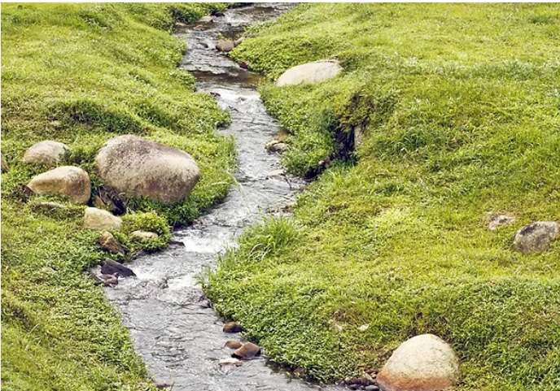 |  |   Year 4 Autumn 1  Topic Overview – Back to the Source  For our topic, we will be learning about the stages of a river and the water cycle. We will also be learning about the Cutty Sark and the tea trade and how the tea was transported along the River Thames.
 |  | Super Start: We will be making our own boats from different materials and investigating if they can float with different weights on them. We will also learn about the Cutty Sark and why it is so famous.  Marvellous Middle: We will be visiting the Cutty Sark and completing a workshop about trade.  Fab Finish We will be using junk material to create our own version of the water cycle. |  |  |  |  |  |  |  | Educational Visit  Visit to the Cutty Sark.
Our Learning Overview
Key Texts
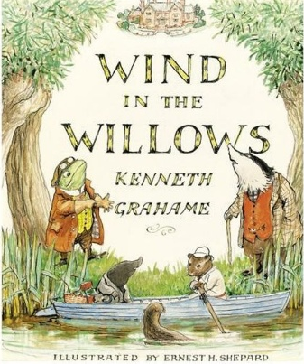
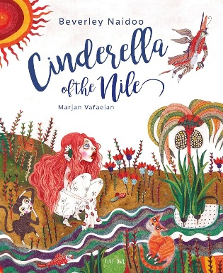

Our PE day is Mondays and we will be learning Tag Rugby.

 |  |  |  |  | English |  | In English, we will be writing a river list poem and writing a non- chronological report about the River Thames. We will also be writing a wishing tale based on our core text ‘A River.’
 |  |  |  |  | Maths |  | We will be learning about place value and partitioning numbers into ones, tens, hundreds and thousands. We will recognize the place value of a digit in a number and use this to order and compare numbers and say which number is more or less.
 | Back to the Source |  |  |  | Science |  | For our Science learning, we will be learning about states of matter where we will be comparing and grouping materials together based on whether they are solid, liquid or gasses. We will also Identify the part played by evaporation and condensation in the water cycle.
 |  |  |  |  | Geography/History |  | In Geography, we will be learning about rivers and the different stages of a river. This will include learning about the water cycle.  In History we will be learning about the Cutty Sark and its links to the tea trade.
 |  |  |  |  | Art |  | In Art, we will be learning about the work of Stephen Whiltshire, this will involve us developing our drawing and sketching skills, including using perspective.
 |  |  |  |  | PSHE/RE |  | Our PSHE topic will be “Being Me in My World.” This will involve learning about feelings, relationships and how to work collaboratively. In RE we will be focusing on Buddhism, answering the question ‘Is it possible for everyone to be happy?’
 |  |  |  |  | Music |  | In Music, students will be using their musical skills to explore the topic of “Mamma Mia”. We will be listening to and appraising music and learning how to sing songs.

