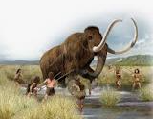 |  |   Year 3 Autumn 1  Topic Overview – Rock of Ages  The children will be using their understanding to: place the prehistoric periods accurately on a timeline, investigate and compare the Paleolithic, Mesolithic and Neolithic periods of the Stone Age and explore the Bronze and Iron Ages and their significance.
Super Start: The children will be creating their own stone age influenced artwork, tools, artefacts and caves.
Fab Finish: The children will create their 3D stone age influenced creations and will present all aspects of their learning during their learning showcase.
Our Learning Overview
Key Texts
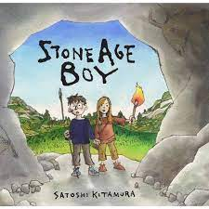
Stone Age Boy

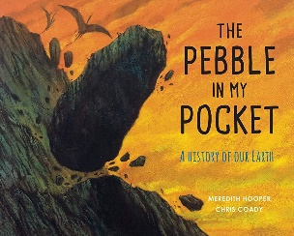
Pebble in my Pocket

 |  |  |  |  | English |  | In English we will start the sterm looking at ‘Inside Out’ and then we will move on to ‘Stone Age Boy’. We will be doing a narrative piece of writing, writing to persuade and a recount.
 |  |  |  |  | Maths |  | Children will be learning about place value, looking at hundreds and thousands. They will be learning to represent and partition these numbers. They will then be moving on to addition and subtraction, in which they will adding and subtracting 10s and 100s, before completing inverse calculations to check their answers.
 | Rock of Ages |  |  |  | Science |  | For our Science learning, we will be naming types of rocks, giving physical features of different types of rocks, explaining how a fossil is formed, classifying rocks in different ways, devising tests to explore the properties of rocks and observing how rocks change over time.
 |  |  |  |  | History |  | In History, we will be exploring the stone age and using evidence to find answers to questions about the past, identify some of the different ways in which the past has been represented and show some of the similarities and differences between different periods.
 |  |  |  |  | DT |  | In DT, we will be exploring levers and linkages and how these are used in everyday life. The children will plan and create a Stone Age gadget that uses linkages. They will evaluate their design using specific criteria and evaluate their final product once changes have been made.
 |  |  |  |  | PSHE/RE |  | During PSHE, the children will recognise their worth and identify positive things  about themselves and achievements. In RE, the children will be learning about Sikhism and will explore and describe a range of beliefs, symbols and actions so that they can understand different ways of life and ways of expressing meaning.
 |  |  |  |  | Music |  | In Music, the children will be learning how to use instruments such as the recorder, glockenspiels and ukulele.

