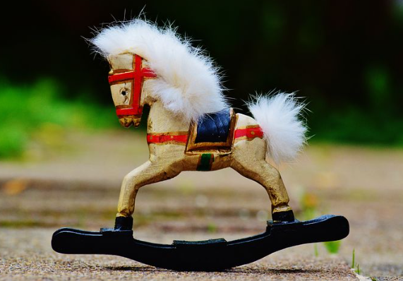 |  |   Year 1 Autumn 1  Topic Overview – Changes in Living Memory  The children will be learning about important dates and events in their own lives and sequencing them on a timeline. They will also explore the differences and similarities between toys and entertainment from the past and present. They will be learning to use different resources to investigate the past.
 |  | Super Start: We will be looking at photos of ourselves and the adults as babies and playing ‘Guess Who!’. We will be exploring old and new toys, schools and forms of transport. We will learn about games children used to play and will have a go at making our own cup and ball toy.  Fab Finish: We will be making puppets and taking part in a puppet show! |  |  |  |  |  |  |  | Educational Visit  Toy workshop at school.
Our Learning Overview
Key Texts

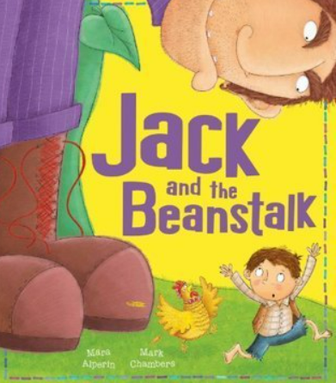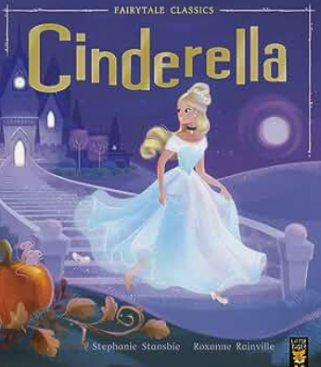
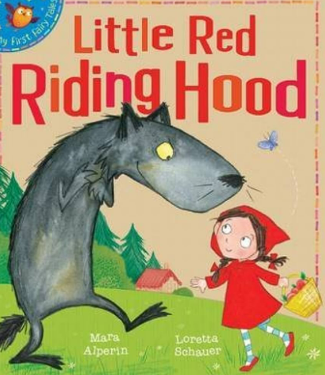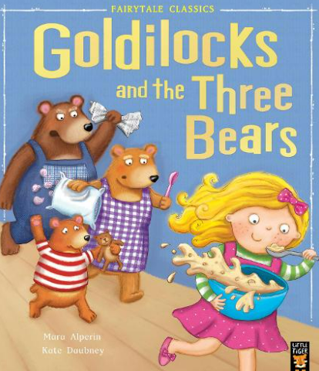
In PE we will be focusing  on fundamental movement skills. |  |  |  |  | English |  | In English, we will be looking at traditional tales such as Goldilocks, Cinderella, Jack and the Beanstalk and Little Red Riding Hood. We will be focusing on our narrative writing so we can consolidate capital letter, finger spaces and full stops.
 |  |  |  |  | Maths |  | In Maths, we be focusing on numbers to 10. We will be ordering numbers and finding one more/less than a number using a range of manipulatives. We will be adding small numbers together and subtracting from a given number.
 | Changes in Living Memory |  |  |  | Science |  | In Science, we will be learning about materials. We will be learning about common types of material that the children might encounter and discussing their properties, e.g. whether things are transparent, malleable, strong.
 |  |  |  |  | History |  | In History, we will be discussing important dates and events in our own lives and we will be sequencing them on a timeline. We will be exploring the differences and similarities between toys, entertainment and schools from the past and present. We will be using different resources to investigate the past.
 |  |  |  |  | Art |  | In Art, we will be exploring puppets made by Paul Klee. We will design and make our own spoon puppets and hold a puppet show for our friends!
 |  |  |  |  | PSHE/RE |  | Our PSHE topic will Being Me in My World. We will talk about what makes us special and how to keep safe. We will be talking about our rights and responsibilities and what makes us proud.
 |  |  |  |  | Music |  | In Music, we will have a music teacher who will show the children how to use tuned & untuned percussion, work on their singing/ensemble work whilst practising performance skills.

