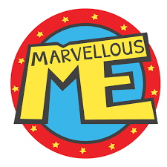 |   Reception Autumn 1  Topic Overview – Magnificent Me  This term in Reception, we will learn through carefully chosen key texts. We will learn through the stories, and follow White Rose Maths. We will start phonics and practise our writing daily.
Super Start: We will undertake many fun activities to launch our topic. Have a look on ClassDojo to see what your child has taken part in.
Marvellous Middle: Children to bring in family photos to share with the class and talk about their families
Epic End Parents and carers are invited in for a family fun session date TBC.
How you can help your child
- Send your child with their book bag every day and a water bottle. Make sure they bring their guided reading book every day in their book bag.
- Encourage your child to change themselves at home.
- Ensure they bring in their P.E kit to school on our PE day (Blue or white t-shirt, tracksuit top and bottoms and plimsolls or black trainers). Please make sure their name is everything that belongs to them.
- Encourage your child to read at home every day.
Our Learning Overview
Key Texts
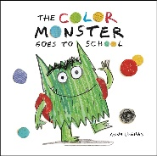
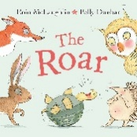
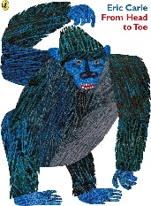
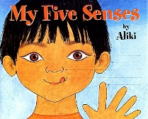
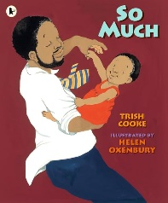

Topic Vocabulary
- Head  - Eyes  - Nose  - Mouth  - Teeth  - Tongue  - Neck  - Shoulders:  - Arms  - Hands  - Fingers  - Chest  - Back  - Stomach  - Legs  - Feet  - Toes | - Happy  - Sad  - Angry  - Excited  - Surprised  - Bored  - Scared  - Proud  - Shy  - Brave  - Confused  - Worried  - Love  - Jealous | - Name  - Age  - Birthday  - Family  - Mum  - Dad  - Brother  - Sister  - Grandparents  - Aunt  - Uncle  - Cousin  - Friend  - Pet | - Wash  - Brush  - Shower  - Bath  - Dress  - Undress  - Sleep  - Eat  - Drink  - Toilet  - Change  - Hands up!. | - Favourite  - Like  - Dislike  - Best  - Colour  - Food  - Drink  - Animal  - Game  - Toy | - Me  - I  - You  - Mine  - Yours  - Same  - Different  - Big  - Small
Core Text Vocabulary
Colour Monster Goes to School | The Roar | So Much | From Head to Toe | My Five Senses
- Colour  - Monster  - Feelings  - School  - Happy  - Sad  - Angry  - Scared  - Excited  - Friend  - Class  - Teacher  - Emotion  - Share  - Learn | - Roar  - Sound  - Fear  - Brave  - Dark  - Forest  - Adventure  - Friend  - Courage  - Danger  - Hide  - Bravery  - Wild  - Explore | - So  - Much  - Love  - Family  - Hug  - Happy  - Together  - Cuddle  - Play  - Big  - Small  - Care  - Important –  - More  - Warm | - Head  - Toe  - Body  - Move  - Stretch  - Arms  - Legs  - Hands  - Feet  - Knees  - Shoulders  - Eyes  - Mouth  - Smile  - Jump | - Senses  - Sight  - Hearing  - Touch  - Taste  - Smell  - Eyes  - Ears  - Skin  - Tongue  - Nose  - Soft  - Loud  - Sweet  - Sour

